PROJECT COLOR SPECIFICATIONS

Main blue colors

* Dark blue: #0d242f | Solid / Alpha 85%
* Light blue: #133545 | Solid / Alpha 85%
* Complementary blue: # 2c4954

**Some examples**

**Dark blue, solid**

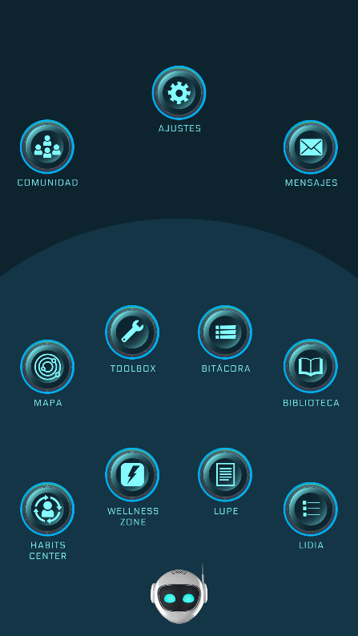

Dark and light blues with 85% alpha are typically used as general backgrounds or specific block backgrounds

**Light blue, solid**

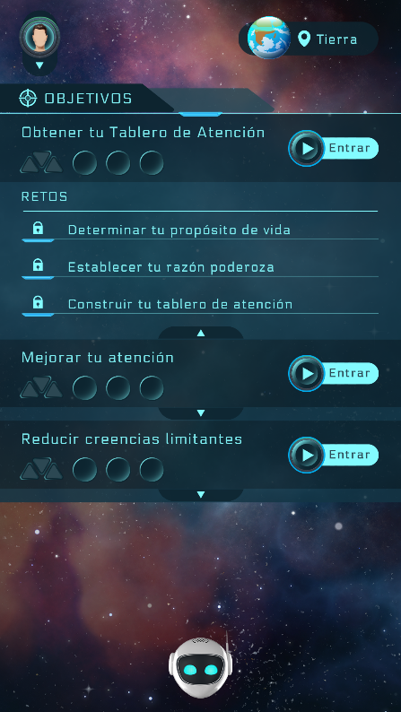 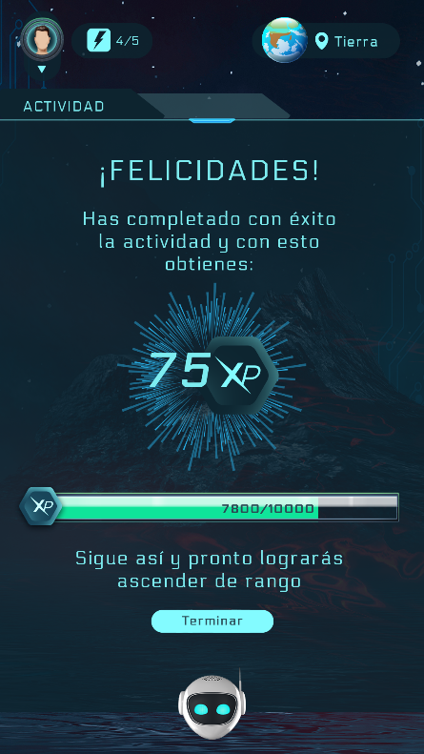

**Dark blue, Alpha 85%**

**Light blue, Alpha 85%**

**Dark blue, Alpha 85%**

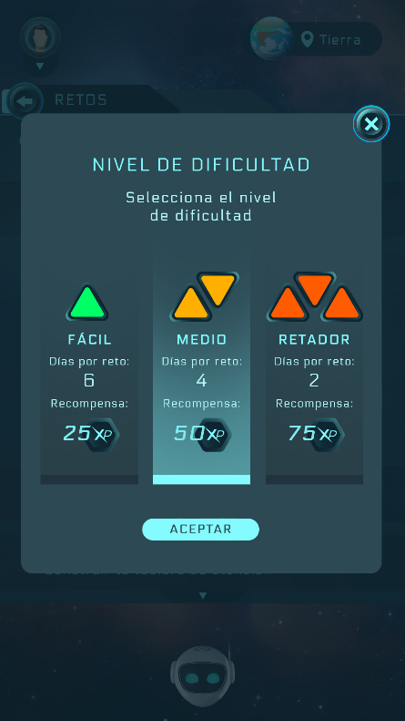 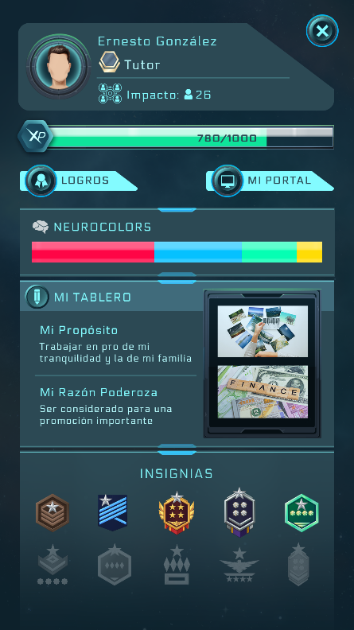

Complementary blue, usually used as the color of pop-up windows and some section backgrounds

**Complementary blue**

**Complementary blue**

Main aqua colors

* Main aqua: #83fbff
* Secondary aqua: #b5f8fb

**Some examples**

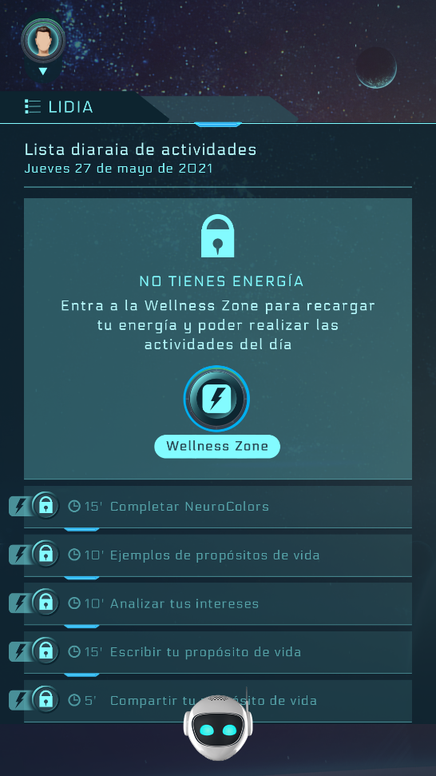

**Main aqua**

Main aqua is used for most contrasting elements such as texts, buttons, icons, etc.

Secondary aqua has limited use, often to differentiate texts within the same screen

**Secondary aqua**

Colors for the activity lists (ToDo and Dailies) depending on their status

The blocks that represent the different states of the activities are created with different alpha levels of the main aqua color (#83fbff), with the exception of the "active" state, which uses a different color as a base that will be indicated below.

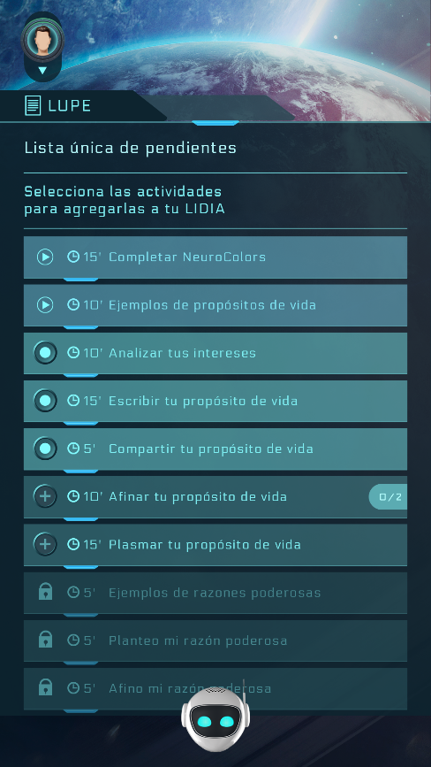**Activity statuses**

**Disabled activity**

Main aqua: #83fbff | Alpha 10%

**Enabled activity**

Main aqua: #83fbff | Alpha 25%

**Active activity**

**Selected activity**

Main aqua: #83fbff | Alpha 50%

**Selected activity**

**Disabled activity**

**Enabled activity**

**Active activity**

COLOR: #83e3ff | Alpha 45%

**Enabled activity**

**Completed activity**

Main aqua: #83fbff | Alpha 50%

Selected activity and completed activity have the same color, the icon is the one that changes depending on the status (they are found on different screens)

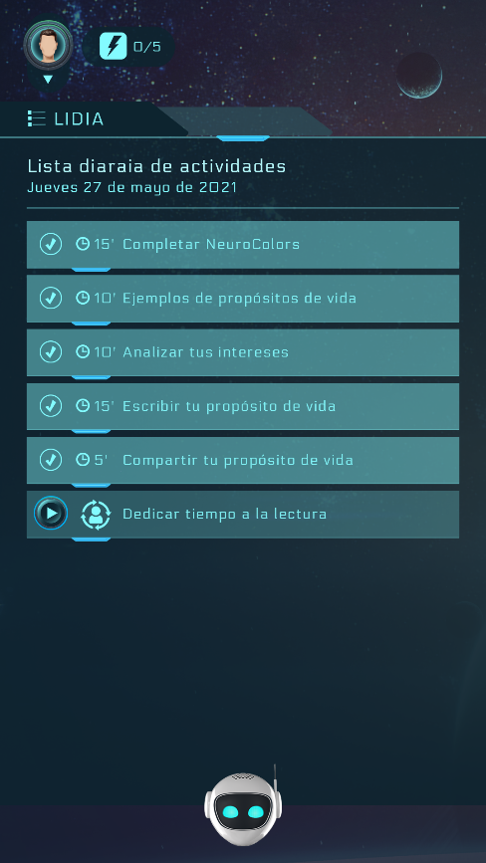

**Completed activity**

The enabled activity has a different icon on each screen (LUPE and LIDIA), since different actions are carried out, however the color is the same in both

**Extra status for the log screen**

In the log section, when a challenge is finished, the background color changes to a new one when it is completed, before this happens, the screen follows the general chromatic logic using the dark and light blues in its blocks.

**Color for finished challenge status:**

* # 3f8aa9 | Alpha 85%

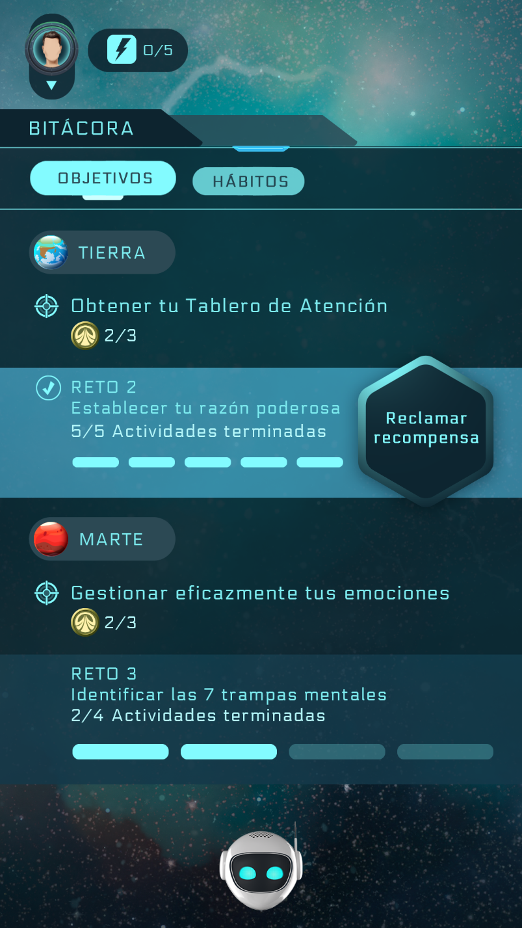

**Finished challenge**

Lines and some blocks

The colors used to create the lines and backgrounds of blocks that appear in the app are specified below.

**Lines**

* Main aqua: #83fbff

Additionally, some lines are accompanied by an ornament that can have different locations, for such cases the graphic " lines_ornament.png" located in the folder " 01 General assets" is added to the line.

**Some examples**

**ornament positioned in the center**

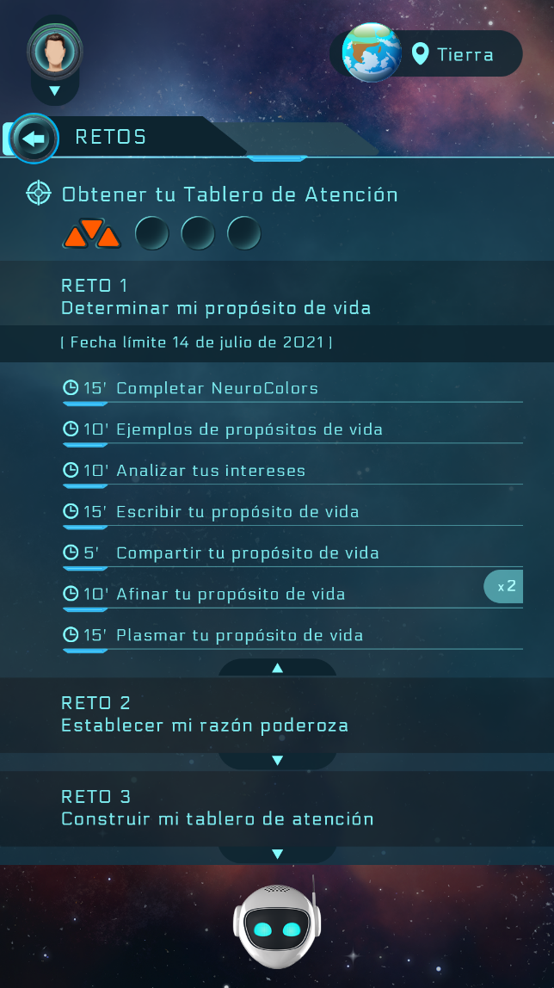 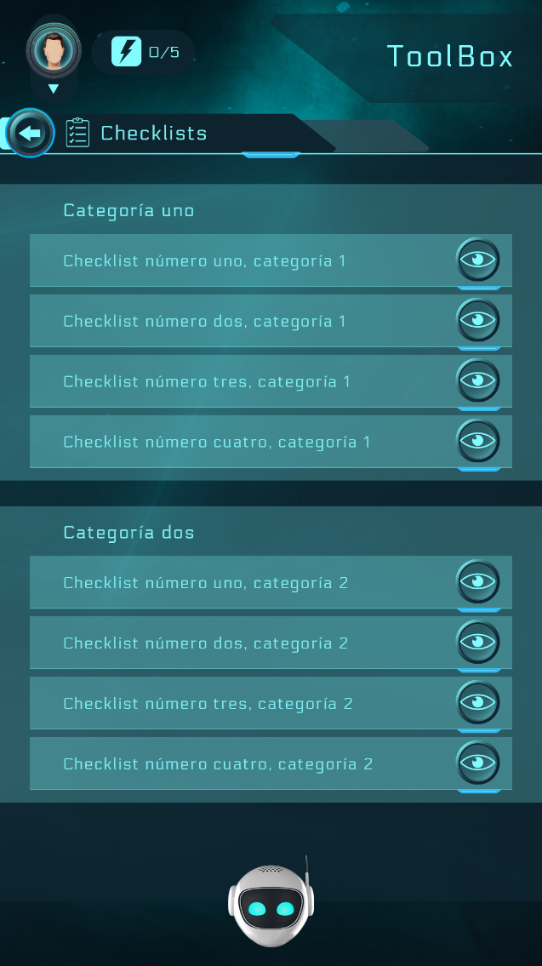

**ornament positioned on the right**

**ornament positioned to the left**

**Blocks**

**Recurrent activity**

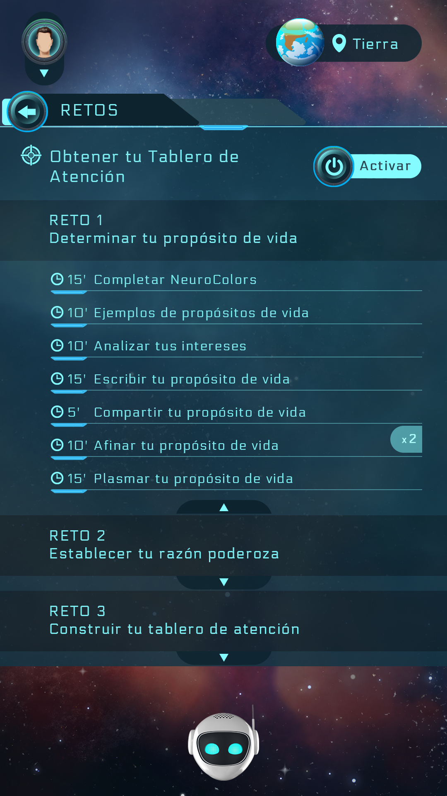

Main aqua: #83fbff | Alpha 50%

**Right/wrong answers**

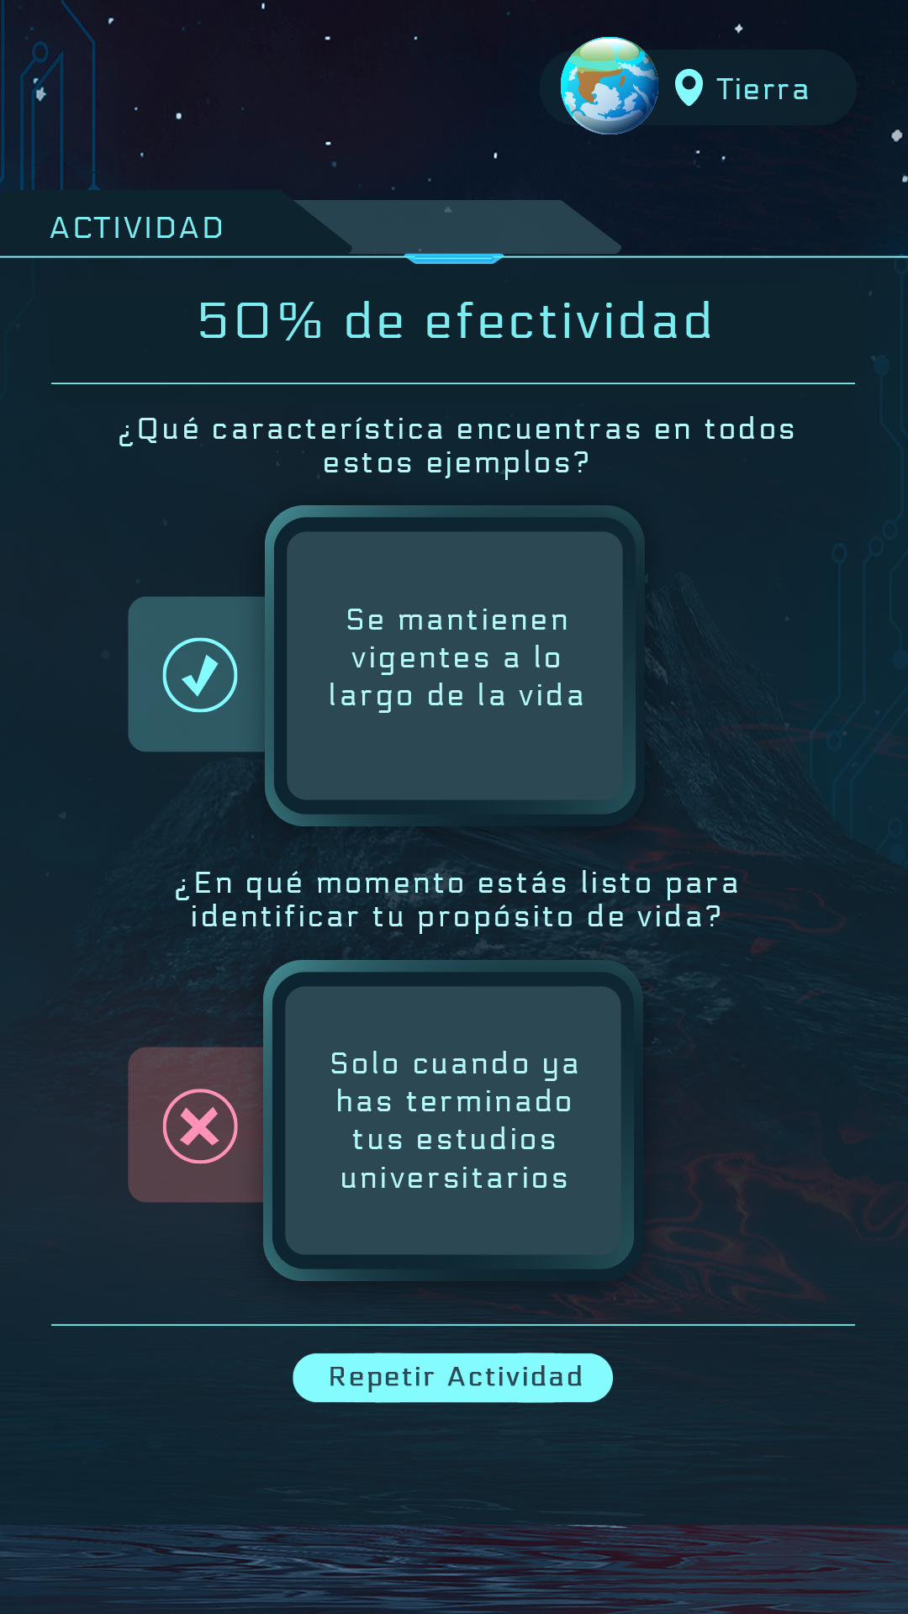

Red: #ff8783 | Alpha 25%

Main aqua: #83fbff | Alpha 25%

**background for numbers**

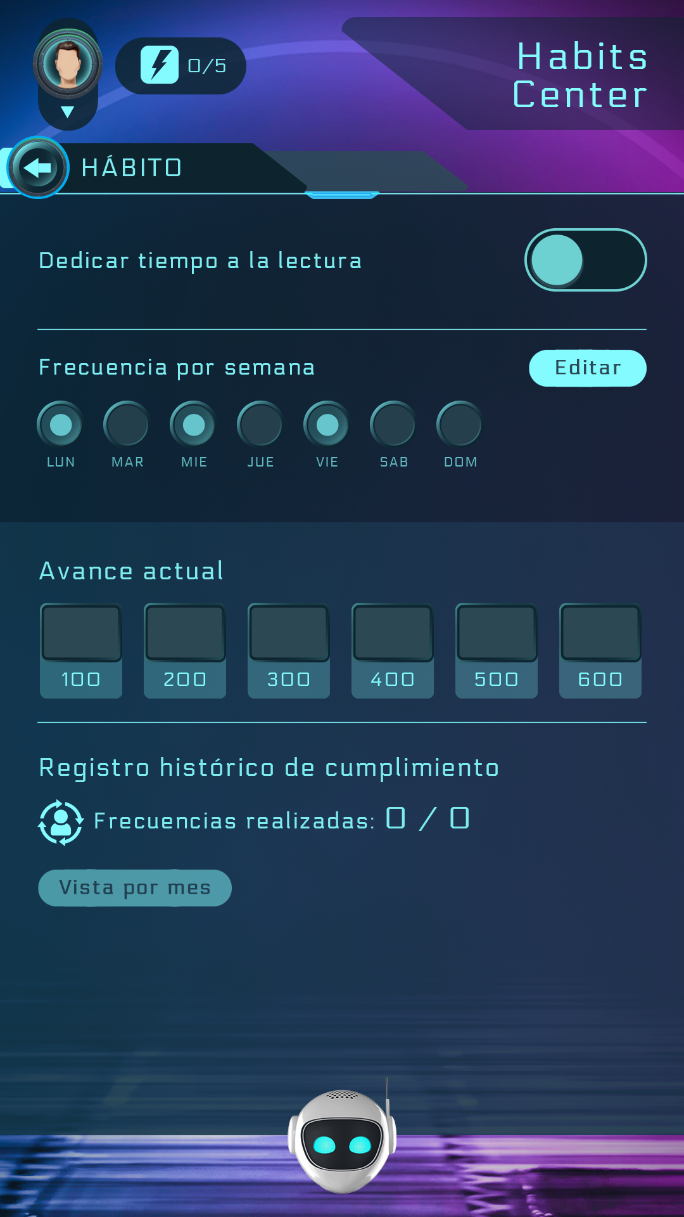

Main aqua: #83fbff | Alpha 25%

**background for text**

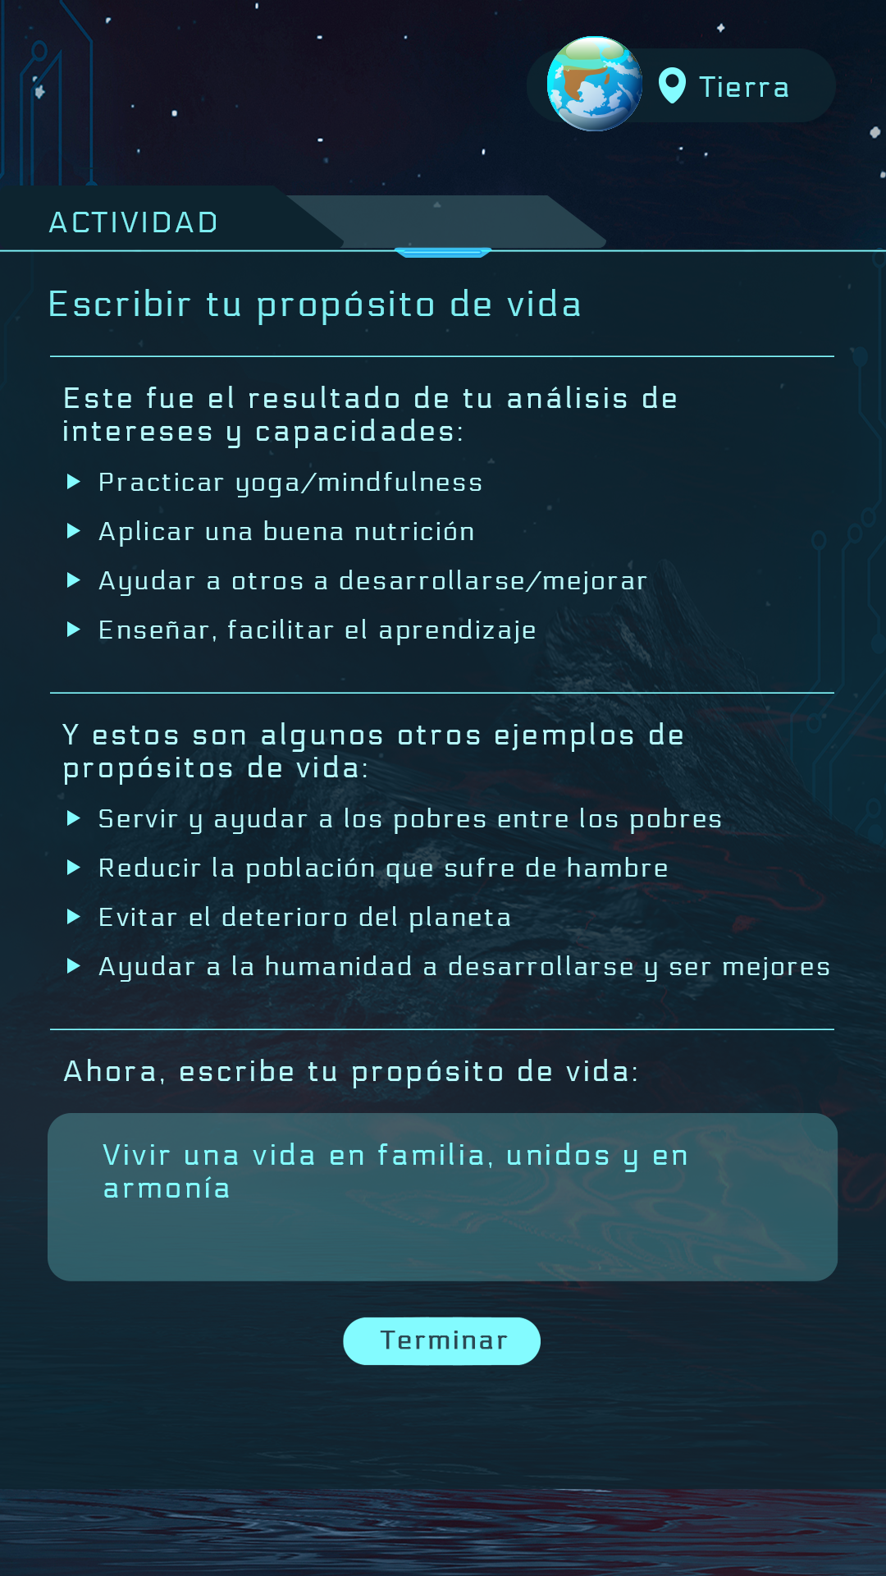

Main aqua: #83fbff | Alpha 25%